Cursors
Operations in a relational database act on a complete set of rows. The set of rows returned by a SELECT statement consists of all the rows that satisfy the conditions in the WHERE clause of the statement. This complete set of rows returned by the statement is known as the result set. Applications, especially interactive online applications, cannot always work effectively with the entire result set as a unit. These applications need a mechanism to work with one row or a small block of rows at a time. Cursors are an extension to result sets that provide that mechanism.

Cursors extend result processing by:
- Allowing positioning at specific rows of the result set.
- Retrieving one row or block of rows from the current position in the result set.
- Supporting data modifications to the rows at the current position in the result set.
- Supporting different levels of visibility to changes made by other users to the database data that is presented in the result set.
- Providing Transact-SQL statements in scripts, stored procedures, and triggers access to the data in a result set.

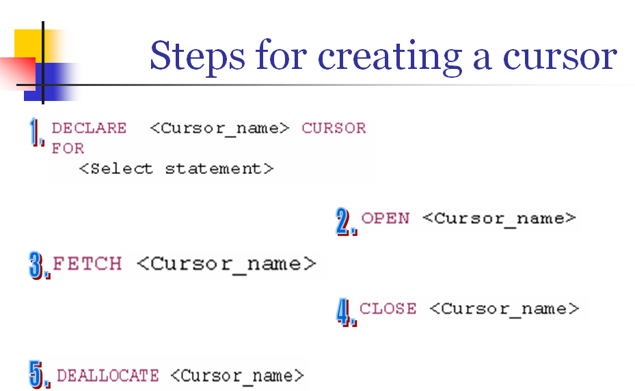

Cursor Mechanism

Step 1-- Declare the cursor (mentioning the select statement, active set)

Step 2 -- Declare variable (s) to hold values given by cursor (optional)

Step 3 -- Open the cursor (Memory allocation)

*Step 4 --

4.1 Fetch first row

4.2 Process it (BL)

4.3 Fetch next row

4.4 Process it (BL)

4.5 Repeat fetch & process till the last row is fetched and processed.

Step 4.2 onwards will be generally in a while loop

Step 5 -- Close the cursor (Access denied) (Optional)

Step 6 -- Deallocate the cursor (some times optional but recommended)

Scroll Attribute – It means that all fetch options such as absolute, next, prior, first,last, relative are available. If Scroll is not mentioned then only Next is available.

Examples

declare c1 cursor SCROLL
FOR SELECT * FROM EMP

OPEN C1
FETCH ABSOLUTE 1 FROM C1
FETCH ABSOLUTE 4 FROM C1

FETCH ABSOLUTE -1 FROM C1 -- From the last record

FORWARD_ONLY

declare c1 cursor FORWARD_ONLY
FOR SELECT * FROM EMP
OPEN C1
Fetch next from C1
FETCH prior FROM C1

(By default cursor is Forward_Only)

declare c2 cursor SCROLL
FOR SELECT * FROM EMP

OPEN C2

FETCH NEXT FROM C2

FETCH PRIOR FROM C2

FETCH Relative 3 FROM C2

FETCH FIRST FROM C2

FETCH LAST FROM C2
Fetching row and giving value to a scalar variable:

declare c9 cursor for
select ename from emp
declare @str varchar(20)
open c9
fetch next from c9 into @str
select @str

Display Ename, Salary and Running Totals using Cursor:

Use Zensar_DB
go
declare cur cursor Scroll
for select ename, sal from Emp
declare @v_ename varchar(20), @v_sal int -- For getting the Ename and Salary of each row
declare @v_rt int -- For the Running Total
declare @v_rows int -- For getting number of rows in the table
declare @v_counter int -- To increment the row number inside loop
set @v_rt = 0 -- Running Total's initial value is 0
select @v_rows = count(*) from emp -- Getting number of rows
set @v_counter = 1 -- Before going in the loop, this will be incremented in the loop
Open cur
Fetch first from cur into @v_ename,@v_sal
set @v_rt = @v_rt +@v_sal
Print @v_ename + ' has salary ' + cast(@v_sal as varchar) + ' and Running Total is ' + cast(@v_rt as varchar)
while @v_counter < @v_rows
Begin -- Start of the Loop
Fetch next from cur into @v_ename,@v_sal
set @v_rt = @v_rt +@v_sal
Print @v_ename + ' has salary ' + cast(@v_sal as varchar) + ' and Running Total is ' + cast(@v_rt as varchar)
set @v_counter = @v_counter + 1
End -- Loop got finished
Close cur
Deallocate cur

Output:

